**Artificially Intelligent Banking ChatBot**

(A Project Report submitted in partial fulfilment of the requirements of Bachelor of Technology

in Information Technology of the West Bengal University of Technology, West Bengal)

Submitted by **Anamika Dey ,  Deepsikha Roy ,  Kaustav Banerjee ,  Moumita Das**  Under the guidance of **Prof. Debabrata Chowdhury** Department of **Information Technology ,** *Kalyani Government Engineering College* (Affiliated to West Bengal University of Technology) Kalyani - 741235, Nadia, WB

**ABSTRACT**

***Chatbots are software agents that interact with the user in a conversation. The main goal of their creation was to resemble a human being in the way they perform said interaction, trying to make the user think he/she is writing to another human being. This has been implemented with varying degrees of success. One of the most popular languages for the definition of a chatbot knowledge base is artificial Intelligence Markup Language (AIML).However this thesis focuses on the implementation of api.ai (dialogFlow.ai) to allow for a web-based client-side specific usage of chatbots. The interpreter must guarantee the compliance of properly formed documents, perform all the necessary pre-processing duties for the correct usage of the chatbot and ensure the correctness of both pattern matching of user input and chatbot response A chatbot is software that is used to interact between a computer and a human in natural language. Naturally, it can extend daily life, such as help desk tools, automatic telephone answering systems, to aid in education, business and e-commerce.***

**I. INTRODUCTION**

A banking chatbot project is built using artificial algorithms that analyses user’s queries and understand user’s message. The system is designed for banks use where users can ask any bank related questions like loan, account, policy etc. This application is developed for web users. The system recognizes user’s query and understands what he wants to convey and simultaneously answers them appropriately. The questions asked by the users can be in any format. There is no specific format for users to ask questions. The built in artificial intelligence system realizes user’s requirements and provides suitable answers to the user. It also uses a graphical representation of a person speaking while giving answers as a real person would do.

**OBJECTIVE**

The purpose of the chat bot is to simulate human conversation between user and the computer. The chat bot architecture integrates a language model and computational algorithm

to emulate information chat communication between a human user and a computer using natural language. The conversation can be in any mode, text or speech and it also implements sentiment analysis. The customer will give his/her image as input and it will get matched with the elements stored in the image database. The system will produce the output based on the knowledge gained from its past experiences using predictive analysis. For front end development, We are using Django for creating interactive GUI.

**II. PROPOSED SYSTEM**

**ARCHITECTURE:**

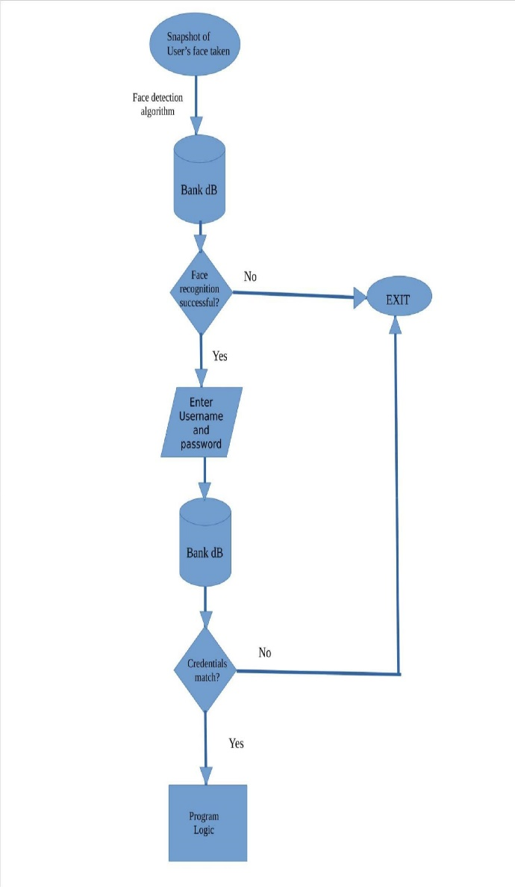

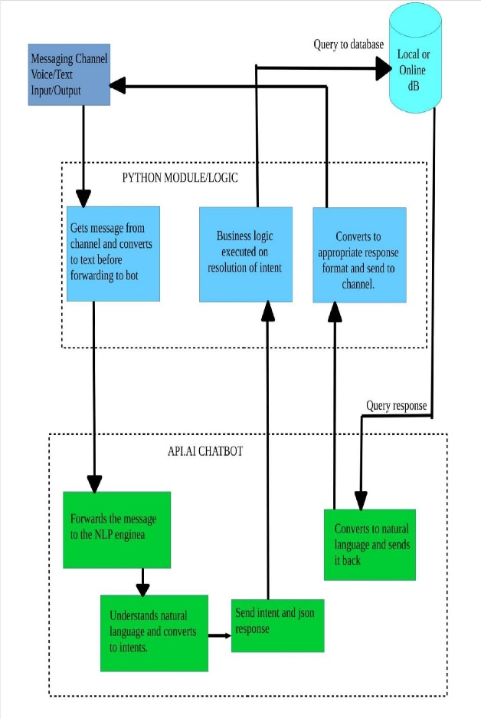**Advantages:**

* This system will help the user by answering the bank related queries.
* User does not have to follow standard format while asking any queries.
* System will answer to the query of the user as if real person is answering to the query.
* The built in artificial intelligence system will realize user’s requirements and provide suitable answers to the user.
* System uses a graphical representation of a person speaking while giving answers as a real person would do.
* Predictive analytics can help banks track the past usage patterns and the daily coordination between the in- and out-payments at their branches and ATM’s, hence predicting the future needs of their potential customers.

**III. METHODOLOGY:**

**Algorithm***:*

First system will take input from user in image format.

* If the given input matches with any of the images in the bank database, then it will the bot will ask for login credentials. If the login credentials get matched properly, then the user will be allowed to access his/her account.
* Finally, the user can ask the bot for further queries regarding the user’s account.

**Module:**

1. Chatbot Users can chat with the bot as if talking to a real banking operative. This part is the core part of our chat bot system. An artificial technology which is new as well as it will help us to create very interactive system. It is very difficult to make decision on user’s query but it is become easier because of the intelligent system. This part is accepting the input in speech form and it will get converted into text format internally. The bot will finally extract the proper query from the input along with analyzing the sentiment of the user.
2. **Text to Speech and Speech to Text:** The bot also speaks out theanswer. Our system will also give output in both format text as well as in voice. Main benefit of audio output is; it is more understandable to user rather than read output.When user interacts with the system, his commands (in speech)get converted into text and further procedure is continued with this and when the system gives output ,it gets converted into speech.
3. **Vader Sentiment Analysis:**[Sentiment analysis](https://en.wikipedia.org/wiki/Sentiment_analysis) is simply the process of working out (statistically) whether a piece of text is positive, negative or neutral. The majority of sentiment analysis approaches take one of two forms: **polarity-based**, where pieces of texts are classified as either positive or negative, or **valence-based**, where the intensity of the sentiment is taken into account. For example, the words ‘good’ and ‘excellent’ would be treated the same in a polarity-based approach, whereas ‘excellent’ would be treated as more positive than ‘good’ in a valence-based approach.VADER (Valence Aware Dictionary and sentiment Reasoner) is a lexicon and rule-based sentiment analysis tool that is specifically attuned to sentiments expressed in social media, and works well on texts from other domains.
4. **Object Detection using python module:**Every object class has its own special features that help in classifying the object. Object recognition is that sub-domain of computer vision which helps in identifying objects in an image or video sequence. With more efficient algorithms, objects can even be recognized even when they are partially obstructed from the direct view.
5. **Predictive model of the system:**The core of predictive analytics relies on capturing relationships between explanatory variables and the predicted variables from past occurrences, and exploiting it to predict future outcomes. Predictive analytics helps banks and financial institutions retain their customers. These are:

* Identifies the customers most likely to defect before they end their relationship.
* Keeps the right customers longer.
* Predicts which actions will earn their loyalty.
* When the system cannot detect the result, it will produce it from the past results using machine deep learning.

1. **Meta Learning perspective:** For large data set handling metalearning perspective can be used. It will be more helpful for us if there is data about stored data (meta data) with which the actual procedure will get continued.
2. **Django GUI:** The user interface is planned to be built using Django.The user first logs into the system through a two-step verification process. 1) Facial Recognition; 2) Login credentials that are loaded from the database.

**Progress:**

* Data retrieving from bank database for any particular request is done.
* Text to speech and speech to text conversion completed.
* Sentiment of the user is being successfully analyzed using vendor sentiment analysis algorithm.
* Extracting the user intent and memorizing the context of conversation for future use in one particular session is still under progress

**Future Plans:**

* User interface of the system is yet to be structured.
* Converting user intent to database management system queries is yet to be done.
* User Identification using face detection is yet to be done.
* Predictive Analysis of the model is yet to be done.

**IV. CONCLUSION**

We are going to implement an intelligent chat bot system for bank, which will give an appropriate response to user’s query. It is an intelligent system which understand and give respond to user. This system will be helpful in reducing workload of employees. This system will take both voice as well as text as an input. If person is not having knowledge about the typing of particular language the system provides voice input facility. This system will be having effective GUI and animation, so that the user feels that he will talking with another person.

**ACKNOWLEDGMENT**

We would like to express our sincere gratitude towards our guide, Mr. Debabrata Chowdhury, for the help, guidance and encouragement, he provides us during this project.

**REFERANCE**

[1] Pyttsx (python module)

[2] SpeechRecognition (python module)

[3] vaderSentiment (python module)

[4] api.ai